GARBAGE-GUARD: DEVELOPMENT OF COMPUTER VISION FOR CREEKS GARBAGE DETECTION USING CONVOLUTIONAL NEURAL NETWORK

A Capstone Study

Presented to the Faculty of the
ELECTRONICS ENGINEERING TECHNOLOGY DEPARTMENT
College of Industrial Technology
Technological University of the Philippines
Ayala Boulevard, Ermita, Manila

by

BRIAN JAY CELESTE
GENESIS WALTER D. REYES II
JADE C. GUNAYAN
KING PERTH G. PEPITO
RODEL S. BANOGBANOG

In Partial Fulfillment for the Requirements of the Degree
Bachelor of Engineering Technology major in Computer Engineering Technology

August, 2026
TABLE OF CONTENTS
TITLE PAGE i
TABLE OF CONTENTS ii
LIST OF FIGURES iii
LIST OF TABLES iv
LIST OF ABBREVIATIONS v
I. INTRODUCTION 1
1.1 Background of the Study 1
1.2 Objectives of the Study 3
1.3 Scope and Limitations of the Study 5
II. LITERATURE REVIEW 7
2.1 Review of Related Studies 7
2.2 Review of Related Patents 16
III. METHODOLOGY 27
3.1 Project Design 27
3.2 Block Diagram 28
3.3 Flowchart 30
3.4 Project Development 32
IV. REFERENCES 41
V. APPENDICES 46
VI. STUDENTS’ BIONOTE 47

LIST OF FIGURES
Figure 1. Garbage Detection Method, Related Equipment and Device 17
Figure 2. Vision garbage classification system and classification method based on TensorFlow 18
Figure 3. WCM-Smart City: WASTE COLLECTION AND MANAGEMENT UNDER SMART CITY USING IOT 19
Figure 4. Cleaning Unit Using Deep Learning for Floating Trash Detection 20
Figure 5. System for Monitoring Water Drainage 21
Figure 6. Drainage Monitoring Apparatus and System 22
Figure 7. Detection and Monitoring of Waste Disposal Using Artificial Intelligence 23
Figure 8. Flood Warning System 24
Figure 9. Method and System for Flood Early Warning in Smart Cities Based on the Internet of Things 25
Figure 10. Apparatus and method for waste monitoring and analysis 26
Figure 11. Garbage-Guard’s System Architecture 27
Figure 12. System Flow of the Waste Detection System 28
Figure 13. Garbage-Guard’s System Flowchart 30
Figure 14. V-Model SDLC Model 32
Figure 15. Garbage-Guard’s Gantt Chart 46
LIST OF TABLES
Table 1. ISO/IEC 25010:2023-based Metrics Descriptions and Scale of Measurements for Garbage-Guard 3
Table 2. Table of Related Patents 16
Table 3. Unit Testing Cases for Controlled Environment Evaluation 37
Table 4. System Testing Cases for Real-World Environmental Conditions 37
Table 5. Acceptance Testing Evaluation Test Cases 38
Table 6. Developer-Side Internal Acceptance Indicators 39
Table 7. End User Side Acceptance Survey Indicators 40
LIST OF ABBREVIATIONS
Abbreviation Definition
AI Artificial Intelligence
CCTV Closed-Circuit Television
CNN Convolutional Neural Network
IEC International Electrotechnical Commission
ISO International Organization for Standardization
RRL Review of Related Literature
SDLC Software Development Life Cycle
UNEP United Nations Environment Programme
UN-SDG United Nations - Sustainable Development Goals
UPS Uninterruptible Power Supply
YOLO You Only Look Once
YOLOv26n You Only Look Once version 26 nano

I. INTRODUCTION

1.1 Background of the Study
Urban waterways such as rivers and creeks have an essential role in urban cities because they work as natural drainage systems, ecological home for animals, and pathways that make water flow easy in these cities. However, the fast growth of cities and rising population numbers have led to a major increase in solid garbage generation throughout many countries around the world, most importantly the Philippines. In urban cities around the country, tons of solid garbage are produced daily, and a portion of that garbage ends up in waterways due to bad mannering of disposal and inefficient garbage collection methods (Development Asia, 2024; UNEP, 2023; World Bank, 2022). Creeks and rivers are an example of major pathways for delivering garbage from areas such as land to sea environments, making them very important points for monitoring pollution (UNEP, 2023; Acot et al., 2022; World Bank, 2022). Also, the growing presence of trash in waterways has become a major concern for the environment, threatening the rivers and urban cities.
One of the major problems about the environment affecting urban creeks is the ongoing collection of solid garbage, including plastics and other non-biodegradable materials. In many urban areas, garbage that has been discarded often add up in waterways and block the natural water flow. Studies have shown that riverbanks and waterways tend to contain the highest level of garbage debris compared with other environments because they act as collection points for floating garbage (UNEP, 2023; Acot et al., 2022; Meijer et al., 2022; World Bank, 2022). In the Philippines, creeks and rivers regularly receive trash from different communities that contribute to water pollution and environmental degradation (Robles & Monjardin, 2025; Meijer et al., 2022; Victoriano et al., 2022). As garbage racks up in these waterways, it also increases the risk of flooding because of the drainage channels being blocked off, reducing waterflow.
The amount of garbage in creeks is often caused by a couple of factors such as bad garbage practices and insufficient garbage management. Research shows that poor performance of solid garbage management programs and lack of awareness contribute really well to the persistence of garbage pollution in rivers and creeks (Development Asia, 2024; UNEP, 2023; World Bank, 2022). People dispose of their garbage from their homes and their activities by dumping it straight into drainage systems and waterways which eventually lead to creeks and rivers. With these factors in mind, they highlight the need for improved monitoring and garbage management strategies.
Several studies and approaches have been made to monitor garbage pollution and detect garbage buildup in waterways. Traditional ways often rely on manual inspections, which can be a hassle and time consuming, especially in large areas (Robles & Monjardin, 2025; Magyar et al., 2023; Victoriano et al., 2022). The improvement of artificial intelligence and computer vision technologies have been widely used for detecting specific objects, especially for environmental monitoring. You Only Look Once (YOLO), is an example of these real-time detection algorithms (Murat & Kiran, 2025; Yaseen, 2024; Kang et al., 2022). Although technologies like this have been applied to monitoring systems, many existing garbage detection solutions rely on imagery from the satellite, or huge sets of data that are not really designed for monitoring in waterways such as creeks.
To address the limits, the integrations of computer visions, deep learning, and real-time monitoring, shows a great solution for garbage detection improvement in creeks. YOLO can analyze video feeds from cameras and can detect garbage materials automatically with good accuracy. This technology can be combined with other platforms that allow environmental managers to monitor the amount of garbage and respond quickly to environmental hazards. This study proposes Garbage-Guard: Development of Waste Detection Using Computer Vision for Creeks, utilizing object detection through a camera to identify and monitor garbage in creeks. With this, providing environmental protection is going to be more efficient.
The research aligns with three UN-SDG which include Goal 6, 9, and 11: (Clean Water and Sanitation), (Industry Innovation and Infrastructure), and (Sustainable Cities and Communities) through its implementation of computer vision technologies for urban environmental sustainability (United Nations, n.d.).

1.2 Objectives of the Study

General Objective
Development of Computer Vision for Creeks Garbage Detection using Convolutional Neural Network and YOLOv26.

Specific Objectives
- To Design a Computer Vision for creeks garbage detection using CNN and YOLOv26n capable of detecting the following:
  - Bottles
  - Bags
  - Plastic / Styrofoam Food Container
- To Develop a Prototype that detects creek garbage and accumulation counter that triggers an automated alert when a customizable threshold (default 20 garbage items detected) reached.
- To Test the system’s performance based on using ISO/IEC 25010:2023, specifically on the characteristics of the following below:
  - Functional Suitability: The accuracy of object classification and accumulation.
  - Performance Efficiency: The real-time responsiveness of Raspberry Pi 5.
  - Usability: Assessing the system’s operability, user interface, the clarity of accumulation alerts.

Metrics Description and Scale of Measurement
Table 1
ISO/IEC 25010:2023-based Metrics Descriptions and Scale of Measurements for Garbage-Guard
Objectives |  | Definitions | Metrics | Description | Scale
1. | Functional Suitability  (Classification) | The ability of the YOLOv26n model to correctly identify and classify solid garbage (bottles, bags, food containers). | Percentage average (%) of correct garbage recognition against total samples tested. | Excellent | 95% - 100%
 |  |  |  | Very Good | 90% - 94.99%
 |  |  |  | Good (Target) | 80% - 89.99%
 |  |  |  | Fair | 70% - 79.99%
 |  |  |  | Poor | Below 70%
2. | Functional Suitability  (Accumulation Detection) | The system’s ability to accurately track the item count and successfully trigger an “Accumulation Alert” once the threshold (default 20 items) is reached. | Percentage average (%) of successful alert triggers out of total simulated accumulation test cases. | Excellent | 95% - 100%
 |  |  |  | Very Good | 90% - 94.99%
 |  |  |  | Good (Target) | 80% - 89.99%
 |  |  |  | Fair | 70% - 79.99%
 |  |  |  | Poor | Below 70%
3. | Performance Efficiency | The inference time and processing latency of Raspberry Pi 5 to draw bounding boxes on the live camera feed on each floating garbage. | Average inference time (in seconds) during real-time monitoring. | Excellent | Below 0.5s
 |  |  |  | Very Good | 0.51s - 1.5s
 |  |  |  | Good (Target) | 1.51s - 3.0s
 |  |  |  | Fair | 3.1s - 5.0s
 |  |  |  | Poor | Above 5.0s
Table 1 shows and defines the metrics that will be used to grade each objective of the Garbage-Guard system based on the ISO/IEC 25010:2023 software quality standards.
(1) The first objective focuses on Functional Suitability (Classification), specifically the accurate measurement of identifying and classifying floating solid garbage such as garbage bottles, garbage bags, and or food containers using the YOLOv26n computer vision model. The computations used to determine the accuracy of the garbage classification utilizing variables from the confusion matrix, where the variables are True Positive (TP), True Negative (TN), False Negative (FN), and False Positive (FP) the formulas are listed below:
Precision$= \frac{TP}{TP+FP}$ , Recall$= \frac{TP}{TP+FN}$ , Accuracy$= \frac{TP + TN}{Total Objects} × 100$
(2) The second objective defines an additional layer of Functional Suitability regarding the system’s Accumulation Detection capability. To mathematically and systematically determine if a creek is polluted, the system tracks the item count and is programmed to trigger an "Accumulation Alert" once a predefined threshold, set to a default of 20 detected garbage items is reached. The parameter is measured by taking the percentage average of successful alert triggers out of the total simulated accumulation test cases conducted by the researchers, utilizing the formula below:
Success Rate$= \frac{Number of Successful Alerts }{Total Number of Trials }$ $× 100$
(3) Lastly, the third objective, Performance Efficiency measures the real-time responsiveness of Raspberry Pi 5. This metric evaluates the inference time and processing latency of the Raspberry Pi 5 to successfully process a live camera feed request and draw bounding boxes on each floating garbage without severe hardware degradation. To ensure an objective evaluation, the system is programmed to automatically log the latency of each frame by subtracting the frame capture timestamp (Start Time) from the detection completion timestamp (End Time). The final parameter is measured by using the averaging method to calculate the mean inference time (in seconds) across a standardized test duration, using the formula:
Average Latency$= \frac{∑ ( T_{End} -T_{Start} )}{Total Frames}$

1.3 Scope and Limitations of the Study

Scope
This study focuses on the development of Garbage-Guard, an automated, computer vision-based floating garbage detection system deployed on an edge computing device, specifically the Raspberry Pi 5. The primary scope of the system encompasses the following:
- Develop an automated floating garbage detection system, Garbage-Guard, using the YOLOv26n algorithm on a Raspberry Pi 5.
- Identify and categorize three specific types of floating solid garbage: Bottles, Bags, and Food Containers.
- Utilize a custom dataset of 2,000 images (1,500 for training and 500 for testing) to achieve a baseline accuracy of at least 80%.
- Execute an item-tracking logic that triggers an "Accumulation Alert" once a threshold of by default 20 detected garbage items is reached but is customizable.
- Deploy the prototype at a local creek or barangay site for real-world environmental testing.
- Deployment of a floating barrier that traps floating surface garbage.
- Evaluate system performance based on ISO/IEC 25010:2023 standards, specifically Functional Suitability and Performance Efficiency only.

Limitations
Despite the capabilities of the Garbage-Guard system, the study is bound by several technical and environmental limitations:
- Detection is limited to items visible on the water's surface; the system cannot identify sunken or heavily obscured garbage.
- Classification is strictly confined to the three target categories (bottles, bags, and food containers) and excludes other pollutants like metal, glass, or organic debris.
- Camera Placement Limitations high or low light can't recognize properly.
- Functionality is limited to monitoring and early-warning alerts; it does not include mechanical garbage collection or water quality analysis.

II. LITERATURE REVIEW

2.1 Review of Related Studies

Environmental Garbage Issues in Philippine Waters
Based on the UNEP (2023) or United Nations Environment Programme, World Bank (2022), and Acot et al. (2022), urban waterways such as rivers and creeks play a critical role in the lives of people living in urban centers. However, due to the effects of rapid urbanization and an ever-increasing population, the amount of solid garbage generated has increased over the years, particularly in the Philippines. The researchers emphasized that a huge volume of garbage generated in the urban area ends up in the waterway due to inappropriate garbage disposal mechanisms. The researchers’ study results revealed that waterways are considered accumulation points for solid garbage originating from the surrounding communities. However, the researchers’ study focused on the garbage management policies and environmental effects rather than the technological aspect. These researchers’ studies are related to the present research because they emphasized the need to monitor garbage pollution in the waterway, such as a creek.

Global Plastic Emission into the Ocean (Meijer et al., 2022)
According to Meijer et al. (2022), rivers are the pathways that check the transportation of garbage from land to ocean. The research showed global modeling and data finding of environmental data to see sources and pathways of garbage in oceans. The research findings saw that a serious amount of garbage was entering the ocean coming from rivers that are mainly in heavy populated environments. However the research was heavily leaning on data analysis and modeling techniques, which is not effective in checking groups of garbage in creeks. This research is similar to the current study, because it shows the dangers of rivers in the transportation of garbage materials.

Multi-Scalar Interactions Between Mismanaged Plastic Waste and Urban Flooding (MacAfee et al., 2023)
MacAfee et al. (2023) checked the interaction of non-organized plastic waste (MPW) and flooding in rapid urbanization and climate change. The review indicates that the rise in the amount of plastic waste in drain channels increases the risks of flooding, especially in coastal cities MacAfee et al. (2023). The limitation of the research is based on the fact that it is based on existing literature without offering technological solutions. The research is relevant in the sense that it emphasizes the need for waste monitoring in the prevention of environmental and social hazards.

Plastic Waste in Marine Ecosystems: Identification Techniques and Policy Interventions (Das et al., 2025)
According to Das et al. (2025), the paper “Plastic Waste in Marine Ecosystems: Identification Techniques and Policy Interventions” reviewed a lot of research papers on marine plastic waste, focusing on techniques and policies that can be intervened. The findings showed that polyethylene and polypropylene are main plastic waste, and the best way to identify plastic waste is by using infrared spectroscopy and AI recognition. The limitations of this research is that it only depended on literature studies and not experiments. The research paper is still relevant to the current study because it showed that waste in water can still be managed.

Wastewater Management in the Philippines: A Call for Localized Solutions and Policy Integration (Corpuz, 2025)
Corpuz (2025) saw the issues in wastewater management in the Philippines. The research saw issues in waste management such as a growing population and poor treatment facilities. This results in wastewater not being treated, being discharged to water bodies. This research used policy review and environmental review as a research method. The limitation of this research is that there is a lack of technology in monitoring wastewater. This is similar because it shows the importance of water checking systems, an objective of Garbage-Guard.

The Impact of Solid Waste Management to the Economic Growth in Selected OECD Countries and Philippines (Ella et al., 2022)
The study by Ella et al. (2022) on the relationship between municipal solid waste (MSW) management and economic growth in selected OECD countries and the Philippines revealed that MSW has a positive effect on GDP per capita. However, the effect of recycling varies by country. The limitations of the study are its concentration on statistical data rather than real-time waste management. This study is similar because it shows the importance of managing waste.

Plastic Waste and Microplastic Issues in Southeast Asia (Ng et al., 2023)
According to Ng et al. (2023) on pollution in Southeast Asia, it is obvious that it lacks structure and poor waste collection practices are bringing an increased level of plastic pollution in water sources. The research earns a review approach and limited citations in data coverage and is dependent on secondary sources. The research is relevant in that it highlights the importance of monitoring and detection of plastic pollution, in which Garbage-Guard helps through computer vision.

Computer Vision Systems

Assessing optimal frequency for image acquisition in computer vision systems developed to monitor feeding behavior of group-housed Holstein heifers, (Bresolin et al., 2022)
According to the study of Bresolin et al. (2022), the computer vision system developed in their study was able to predict the identity of each group-housed heifer when they were at the feed bunk with the head through the feed rail. It is associated with feeding behavior, with high accuracy. The results showed that the optimal image acquisition frequencies are phenotype. This is relevant to the researchers’ study as it gives us the importance of reducing the amount of data generated by using a lower image acquisition frequency in the reduction of interference time, data transfer, and data storage costs.

A Survey of Computer Vision Detection, Visual SLAM Algorithms, and Their Applications in Energy-Efficient Autonomous Systems (Chen et al., 2024)
According to the study of Chen et al. (2024), computer vision serves as a foundational element in the realm of intelligent systems and AI technologies. It can effectively replace traditional sensors as the primary source of data input, acting as a pair of intelligent "eyes" that can more adeptly process data sources to drive a range of unmanned operations, such as autonomous driving, obstacle avoidance, and detection tracking. This study is relevant to researchers’ study as we integrate with computer vision to detect waste in creeks in real time.

IoT-driven Smart Warehouses with Computer Vision for Enhancing Inventory Accuracy and Reducing Discrepancies in Automated Systems (Ayoola et al., 2024)
According to the study, Ayoola et al. (2024) prove that computer vision can be used to enhance inventory accuracy and reduce discrepancies, which are two of the biggest pain points in modern-day supply chains. In their paper titled “IoT-driven Smart Warehouses with Computer Vision for Enhancing Inventory Accuracy and Reducing Discrepancies in Automated Systems,” they highlight the importance of computer vision in reducing discrepancies. This can be relevant to researchers’ study as we use computer vision that is accurate and efficient.

Automatic detection of falling hazards from surveillance videos based on computer vision and building information modeling (Yang et al., 2022)
According to the study of Yang et al. (2022), Their study "automatic detection of falling hazards from surveillance videos based on computer vision and building information modeling", takes computer vision instead of sensor systems as an information exchange between the physical construction site and virtual model. The objective of their study is to propose a deep learning-based approach to achieve bi-directional information exchange from physical construction sites to digital models. This is relevant to researchers’ study as it gives us an idea about the data set they use in detecting on-site safety risks, relating to researchers’ study in which the computer vision will be detecting garbage in the creek water.

Machine-learning-assisted classification of construction and demolition waste fragments using computer vision: Convolution versus extraction of selected features (Nezerka et. al., 2024)
According to the study of Nezerka et. al., 2024, to address improper sorting of construction and demolition waste that leads to significant environmental and economic implications, they developed a machine-learning-assisted procedure for recognizing construction and demolition waste fragments using an rgb camera. It resulted in an overall 85.9%, offering a pathway for efficient and accurate waste sorting. It can be relevant to researchers’ study as it relates to detecting waste using computer vision.

A computer vision-based lane detection technique using gradient threshold and hue-lightness-saturation value for an autonomous vehicle (Al Noman et. al., 2022)
According to the study of Al Noman et. al. (2022) "A computer vision-based lane detection technique using gradient threshold and hue-lightness-saturation value for an autonomous vehicle" the system uses computer vision-based technologies to identify road lines. The left and right lanes on the roads are determined via sliding window searching technique. The system works with 96% accuracy and the positive rate is 0.640%. The accuracy and the efficiency of the system could be developed by increasing computer features and applying deep learning algorithms along with the proposed study.

A Survey of Deep Learning-Based Object Detection Methods and Datasets for Overhead Imagery (Kang et al., 2022)
According to Kang et al. (2022), computer vision technology has enhanced the processing of objects in high-resolution overhead images taken by drones, airplanes, and satellites. The technology has been applied in real-world applications like crop analysis, economic analysis, and disaster tracking. Despite the advancements, object detection in overhead images is still a challenge due to the volume of images, resolution, size of objects, and complexity of the background.

A comprehensive review on YOLO versions for object detection (Murat & Kiran, 2025)
Similarly, Murat & Kiran (2025) described that object detection algorithms have undergone a tremendous transformation with the application of deep learning technology. Among the most popular algorithms is YOLO, which is famous for its fast and accurate real-time object detection. The researcher has reviewed the various versions of YOLO, including YOLOv1 to YOLOv11, and described the advancements in the architecture and performance of the algorithm.

What is YOLOv8: An In-Depth Exploration of the Internal Features of the Next-Generation Object Detector (Yaseen, 2024)`
Moreover, Yaseen (2024) has examined YOLOv8 and described the advancements of the algorithm over the previous versions. The algorithm applies advanced architectures such as CSPNet and FPN+PAN, along with an anchor-free technique, to enhance the feature extraction and multi-scale detection. The algorithm has been tested on datasets such as Microsoft COCO, demonstrating the accuracy and real-time detection capabilities of YOLOv8.

Smart Environmental Monitoring Systems

Advances in real-time smart monitoring of environmental parameters using IoT and sensors (Narayana et al., 2024)
In the research conducted by Narayana et al. (2024), environmental conditions are made up of both living and non-living components that affect human life. Non-living components include land, water, stones, and the atmosphere, while living components include organisms such as plants, woodlands, fisheries, and wildlife. Human life, particularly for people who practice activities such as farming, sailing, traveling, and mining, is affected by environmental variables such as temperature, humidity, pressure, air quality, greenhouse gases, wind speed and direction, rainfall, soil pH, soil moisture, water availability, light intensity, and turbidity.
In addition to that, to address the issue of monitoring environmental variables and to mitigate the challenges that come with monitoring environmental parameters, IoT technology was used to develop IoT-based smart environmental monitoring systems. This technology uses microcontrollers and other technologies to monitor environmental parameters from different locations and send the data to a website for monitoring and observation remotely using IoT technology. IoT technology is a dynamic system that observes and responds to environmental variables and conditions (Narayana et al., 2024)

Sensors on Internet of Things systems for the sustainable development of smart cities: A systematic literature review. (Zeng et al., 2024)
In the study of Zeng et al. (2024), the integration of IoT technology into smart city systems has several advantages in the management of the environment, as it allows real-time monitoring of important parameters such as air quality, water quality, noise levels, soil quality, and others. This has enabled city administrators to proactively manage the resources of the city in a cost-effective manner. These parameters have collectively proven the importance of IoT sensors in achieving sustainability in the environment.

Advancements in air quality monitoring: a systematic review of IoT‑based air quality monitoring and AI technologies (Garcia et al., 2025)
Expanding on these capabilities, Garcia et al. (2025) show how Internet of Things (IoT) technologies have greatly improved environmental monitoring by allowing a network of low-cost sensors to continually produce large amounts of real-time data on air quality. This is further enhanced when these IoT systems are used with artificial intelligence techniques such as machine learning and deep learning. This improves the accuracy of environmental evaluations. The IoT-based systems used for monitoring are able to monitor various aspects of air quality, including particulate matter, carbon dioxide, nitrogen dioxide, ozone, and volatile organic compounds. This makes them an efficient means of conducting a thorough surveillance of the environment. This is a clear example of how integrated IoT and artificial intelligence-based systems can improve decision-making regarding environmental management.

Applications of machine learning & Internet of Things for outdoor air pollution monitoring and prediction (Gryech et al., 2024)
In the recent literature of Gryech et al. (2024), it has been observed that there is a rising trend towards the inclusion of IoT technologies with machine learning methods for better outdoor air pollution prediction and forecasting. Though the traditional air pollution stations are accurate, the high cost of these stations has encouraged the development of IoT-based low-cost sensors, along with machine learning methods that are capable of predicting the levels of outdoor air pollution through time-series, feature-based, and spatio-temporal methods, although the limitations of the lack of diversity in the data and the context-specific features have to be addressed, as identified by the recent literature.

Urban form and seasonal PM2.5 dynamics: Enhancing air quality prediction using interpretable machine learning and IoT sensor data (Lee et al., 2024)
Urban air pollution, including particulate matter (PM2.5), is a significant threat to public health. The increased density of urban areas, along with motorization, has contributed to the complexity of air pollution. The traditional methods used to monitor air pollution have been inadequate, leaving many gaps in understanding localized phenomena. The researchers used IoT sensor network data, along with interpretable machine learning techniques such as random forest regression, to study a large amount of data on environmental conditions during different seasons, including various types of urban forms, which has enabled them to achieve a high accuracy rate while gaining a deeper understanding of various aspects of air pollution. (Lee et al., 2024).

A smart IoT urban flood monitoring system using a high‑performance pressure sensor with LoRaWAN (Te et al., 2024)
One of the significant environmental issues experienced in the Philippines has been flooding, which has been attributed to monsoon rains, the topography of the area, and inadequate drainage systems. This has been a major cause of loss of lives and properties, especially in the urban area. In order to address the issue of delay associated with flood monitoring, Te et al. (2024) proposed the development of a smart IoT-based flood monitoring system for an urban area. This would entail the incorporation of efficient pressure sensors, LoRaWAN, and solar power. From the reviewed background of the research, it is clear that there is a need to utilize IoT to address the issue of disaster, as it would allow for efficient monitoring to enhance the flood response strategy (Te et al., 2024).

Development of a secured IoT‑based flood monitoring and forecasting system using genetic‑algorithm‑based neuro‑fuzzy network (Arante et al., 2025)
The monitoring and forecasting of floods in the Philippines are important due to the occurrence of heavy rains and typhoon scenarios, which cause the rapid rise of water levels. In this regard, Arante et al. (2025) contextualized their research by highlighting the limitations of the existing flood monitoring systems, which are not effective in the Philippines, and the need to develop a secure IoT infrastructure to transmit data on water levels to aid in the prediction of floods. The authors proposed a neuro-fuzzy LSTM machine learning model to improve the accuracy of flood event prediction, which is a form of smart environmental monitoring system in a water-related disaster scenario.

2.2 Review of Related Patents
Table 2
Table of Related Patents
Patent Title | Author | Adopted Feature | Enhanced Feature
Garbage Detection Method, Related Equipment and Device | Li & Wang (2020) | Image recognition to detect garbage | Enables automatic garbage detection in areas.
Vision garbage classification system based on TensorFlow | Wu et al. (2019) | The AI system classifies garbage usingTensorFlow. | Using similar A system, it improves garbage recognition using deep learning model like YOLOv8
Smart City Waste Collection and Management using IoT | Chordiya et al. (2020) | IoT Sensors monitor garbage compiling systems. | Using a camera for real-time monitoring of garbage
Cleaning Unit Using Deep Learning for Floating Trash Detection | Hyun-dong et al. (2019) | Uses object detection to identify trash | Enhances garbage identification using AI algorithms.
Drainage monitoring apparatus and system | Campbell et al. (2022) | Water level sensors monitor drainage conditions and detect faults. | Detects garbage as a cause of drain blockage in waterways.
System for monitoring water drainage | Den Hartog & Voncken (2017) | Sensors monitor water levels in drain systems. | Detects water blockage and water conditions.
Detection and monitoring of waste disposal using artificial intelligence | Liu et al. (2022) | AI monitors garbage in the environment | Tracks garbage data using automated analysis.
Flood warning system | Torres et al. (2024) | Sensors detect rising water levels. | Alerts user when garbage buildup cause flooding
Method and System for Flood Early Warning in Smart Cities Based on the Internet of Things | Shao et al. (2023) | IoT sensors monitor rainfall and water levels | Garbage detection as an early indicator of flooding risk
Apparatus and Method for Waste Monitoring and Analysis | Balachandran & Talavera (2023) | Sensors and cameras monitor garbage levels in containers. | Automates garbage detection using Computer Vision analysis
Figure 1
Garbage Detection Method, Related Equipment and Device (Li & Wang, 2020)
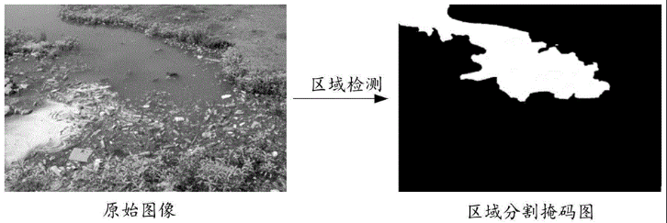
In Figure 1, Chinese researchers have made a garbage detection method using image recognition. The system takes pictures of monitored rivers and processes them to find garbage. This technology can be used in different urban areas such as lakes and parks. It analyzes captured images to think whether garbage objects are visible in the environment. In this patent’s case, it relates to Garbage-Guard because it can use computer vision to detect garbage, similar to the researcher’s proposed system that detects garbage in creeks.
Figure 2
Vision garbage classification system and classification method based on TensorFlow (Wu et al., 2019)
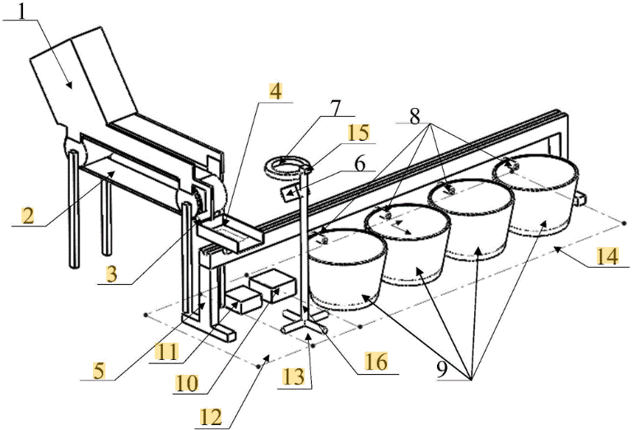
In Figure 2, this patent which uses computer vision, is a Vision Garbage Classification System and Method based on TensorFlow made by Wu et al. (2020). The system uses images of garbage items and puts them into a model trained on garbage images. Methods include data collecting, image processing, and automatic classification of garbage categories. This patent is similar to the researcher’s present study because it also uses the application of computer vision and machine learning techniques but for automated garbage detection.
Figure 3
WCM-Smart City: WASTE COLLECTION AND MANAGEMENT UNDER SMART CITY USING IOT (Chordiya et al., 2020)
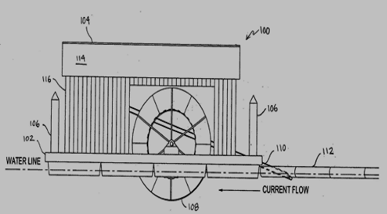
Figure 3 is a patent from Chordiya (2020), describing their study as a waste collection system made for grabbing garbage in rivers and streams. This invention uses a conveyor mechanism that collects waste and transports it into a container. It incorporates monitoring systems with sensors that detect waste levels and can transmit that information to a platform. This patent demonstrates the use of automatic methods for technologies in managing garbage, it is similar to the researcher’s Garbage-Guard system that aims to find garbage in creeks using computer vision technology.
Figure 4
Cleaning Unit Using Deep Learning for Floating Trash Detection (Kim et al., 2019)
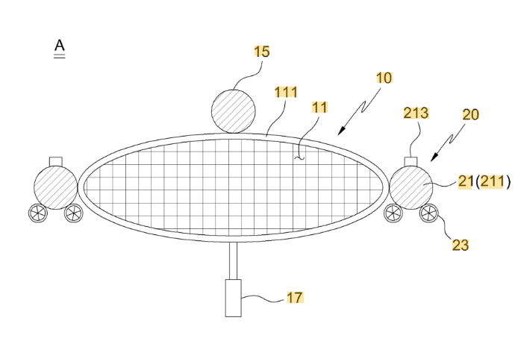
Figure 4 is a similar patent that is related to garbage detection from South Korea. It is a water-surface cleaning unit that uses deep learning technology to detect floating garbage made by Kim et al. (2019). The system integrates a camera module with a deep-learning model which helps in locating garbage on water surfaces. Then, it activates a mechanism that collects the debris from the water. This type of invention shows how relevant it is to the researchers’ study because it is similar to how artificial intelligence is used for garbage detection in water environments.
Figure 5
System for Monitoring Water Drainage. (Den Hartog & Voncken, 2017)
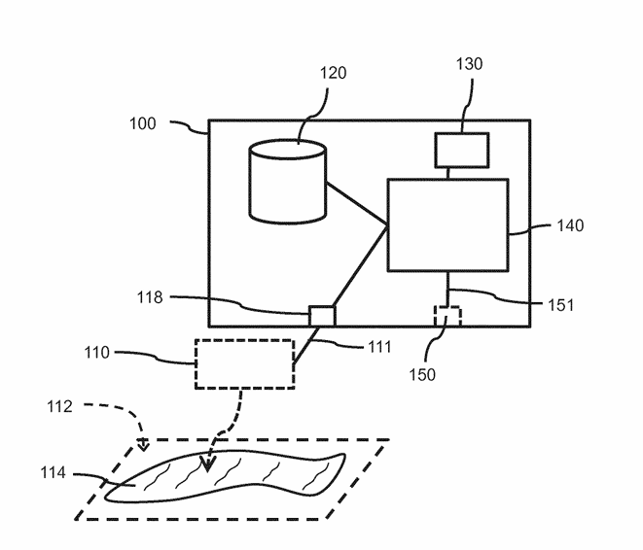
Figure 5, in terms of smart drainage systems, this figure from a patent made by Den Hartog and Voncken (2017) patented a system that is designed to check water drainage environmental sensors. The system collects data from water presence on surfaces and compares it with predicted water drainage conditions based on what happens during rainfall. If the detected water remains longer than usual, the system makes warning signals about potential drainage problems. This type of technology integrates sensors, weather information, and data processing to check drainage conditions. This type of patent is related to Garbage-Guard because both of the systems required to monitor water environments, by detecting garbage being collected in creeks, which may cause drainage issues.
Figure 6
Drainage Monitoring Apparatus and System (Campbell et al., 2022)
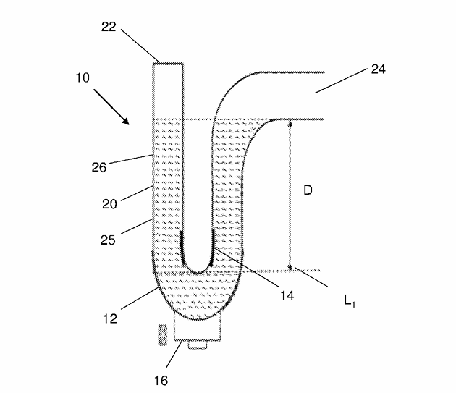
Figure 6 is an another patent related to smart drainage monitoring systems, is this patent from Campbel et al. 2023, which showcases a drain monitor apparatus designed to look at water levels within building drainage systems. The invention uses a water trap equipped with a water level sensor that checks the level of water inside the drainage trap. When the water level drops to a specific point, the sensor sends a signal to a system or mobile application that can make audible alerts to inform that there are drainage faults. This technology is relevant to Garbage-Guard since it is similar to how the systems monitor drainage systems. However, instead of detecting water levels, it detects the various amounts of garbage in creeks using computer vision.
Figure 7
Detection and Monitoring of Waste Disposal Using Artificial Intelligence. (Liu et al., 2022)
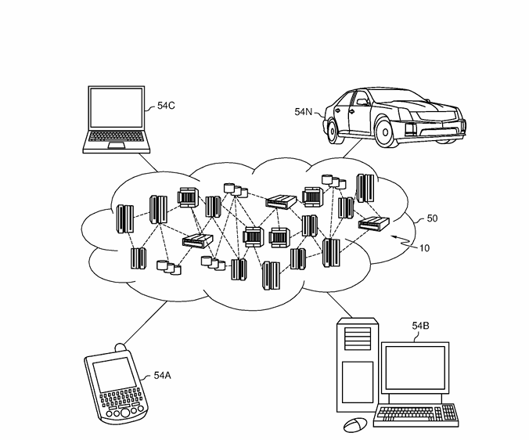
Figure 7 patent by Liu et al. (2022) made an artificial intelligence system for detecting waste in environmental locations, just like natural environments. The system collects images using sensors or cameras and gives them to machine-learning algorithms that check waste objects. Then, the system tracks waste accumulation patterns and finds the location and size of garbage in monitored areas. This patent is similar to Garbage-Guard’s usage of Artificial Intelligence and image analysis to find garbage in different locations.
Figure 8
Flood Warning System (Torres et al., 2024)
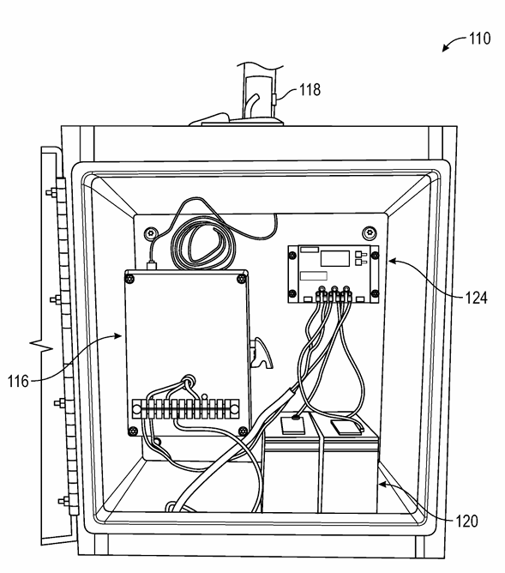
Figure 8 patent by Torres et al. (2024) made a flood warning system to provide early warnings for floods using monitoring systems. It includes multiple of these in monitoring stations near rivers or drainage channels. Each of these are equipped with sensors that monitor water level and rainfall accumulation. That collected data is connected wirelessly to a flood warning station, where it is checked to determine whether the water level exceeds the thresholds. When a flood risk has been shown, the system will make visual alerts that are sent to users through mobile devices. This patent is useful and similar to Garbage-Guard’s system, since warning systems are important in monitoring the environment and can notify when the creeks are filled with garbage.
Figure 9
Method and System for Flood Early Warning in Smart Cities Based on the Internet of Things (Shao et al., 2023)
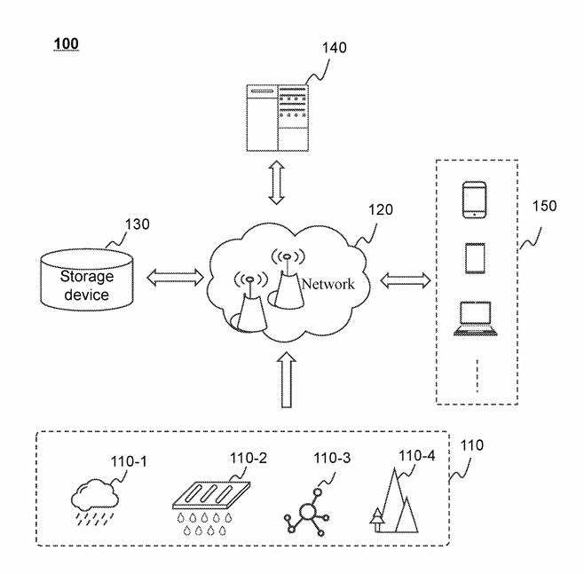
The patent at Figure 8 from Shao et al. (2023), made a smart flood early warning system that has Internet of Things (IoT) with data to detect potential flooding conditions in urban places. This system collects precipitation information from weather stations and combines it with the data from the sensors to estimate water level in specific areas. This invention is similar to Garbage-Guard where they involve environmental monitoring and alerts.
Figure 10
Apparatus and method for waste monitoring and analysis (Balachandran & Talavera, 2023)
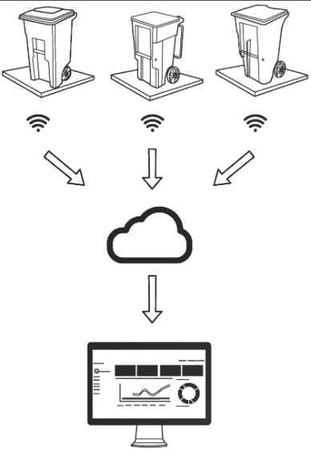
In Figure 10, a patent by Balachandran & Talavera (2023) invented a waste monitoring and analysis system, made for analyzing waste collected in containers. It uses sensors such as load cells and cameras to measure the weight and type of waste material placed inside bins. That data is collected and given to a cloud platform where it can be analyzed. With this information, it can define the pattern of the trash disposals, and make reports about waste generation. This patent is relevant to Garbage-Guard because it shows how sensor based systems can monitor and analyze data in real time. The invention focuses on detecting waste garbage collection in creeks using computer vision technology.

III. METHODOLOGY

3.1 Project Design
Figure 11
Garbage-Guard’s System Architecture
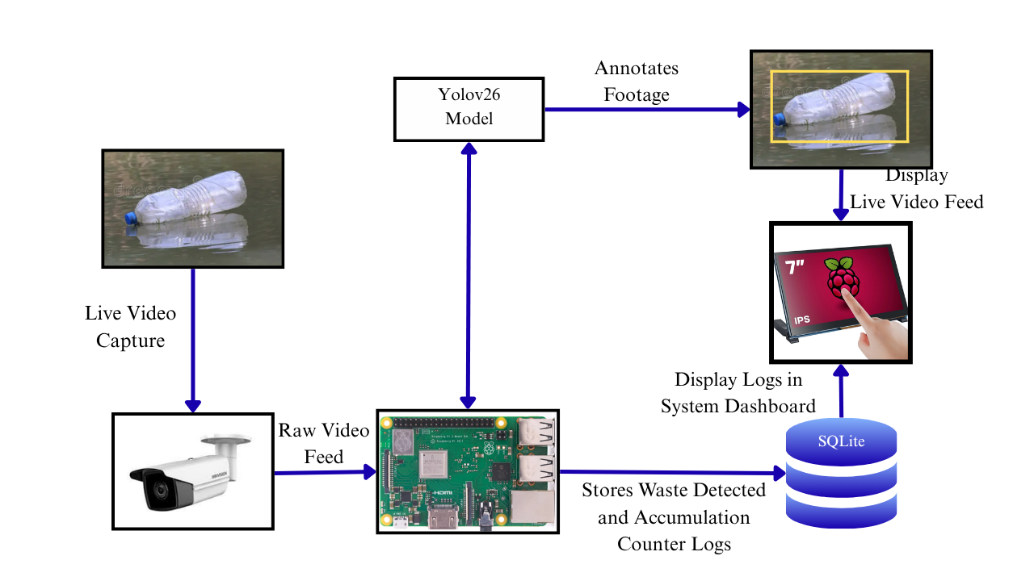
The project design highlights essential components, structure, and processes required to achieve the study's objectives. It includes hardware and software integrations, block and flow diagrams, and the sequential operations necessary for the system's functionality.
The proposed Garbage-Guard prototype should auto-detect floating garbage materials while monitoring a creek. With this, it employed a high-definition CCTV camera wherein real-time videos are being used, then applied the YOLOv26 object detection algorithm; thus, able to classify whether the objects floating on the water are bottles, bags, or food containers accurately wherein all these processes are done inside the Raspberry Pi 5 edge computer as seen in Figure 11.
The prototype includes the following components:
- Input: Live video footage of the creek surface recorded by a CCTV camera.
- Processing: Using YOLOv26 algorithm executed on a Raspberry Pi 5 to analyze real-time video for the classification and counting of floating solid garbage.
- Storage: Results of the detection and accumulation logs are stored in a SQLite database for further analysis and report generation.
- User Interface: The real-time detections and accumulation alerts are shown on a touchscreen monitor with summarized data and analytics for the user.
The system will work in real-time, so it will not only help local authorities with insights to enforce environmental regulations but also minimize severe pollution in local waterways. By providing immediate feedback on garbage accumulation, the system promotes better ecological management and awareness among communities. This proactive approach contributes to creating cleaner waterways, reducing environmental health hazards, and enhancing compliance with proper garbage disposal standards.

3.2 Block Diagram
Figure 12
System Flow of the Waste Detection System
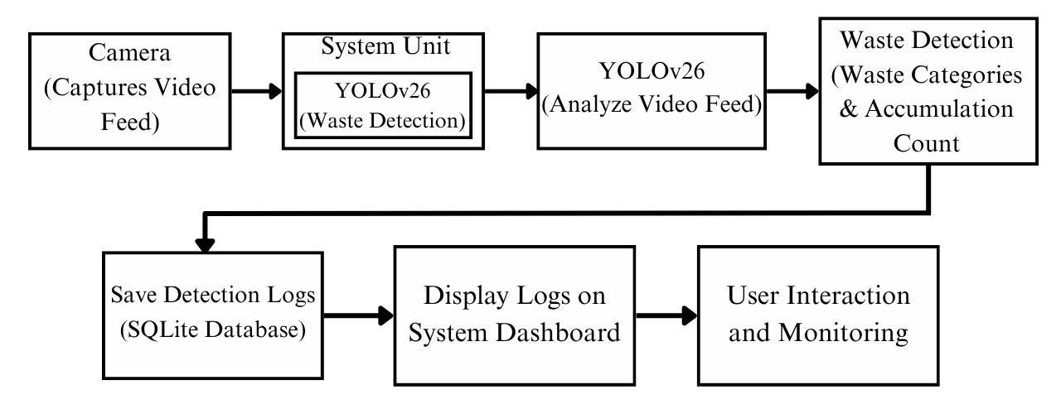
The block diagram in Figure 12 demonstrates how the integration of the YOLOv26 algorithm, an edge computing device (Raspberry Pi 5), and a CCTV camera makes real-time garbage detection and data storage more efficient.
After system initialization, the camera captures a live video feed of the targeted water surface. This feed is transmitted to the main processing unit, the Raspberry Pi 5, where the YOLOv26 algorithm analyzes the footage in real-time to classify floating solid garbage and track the current item count. The system shows the annotated results in real-time and allows users to view the live dashboard, monitor accumulation alerts, and access data. The main processing unit handles crucial decision-making by triggering an alert when the detected garbage threshold (default 20) is reached. Furthermore, it securely stores relevant information regarding the detected garbage categories, timestamps, and accumulation events in the local database for future examination. Through this seamless integration of hardware (Raspberry Pi 5 with a camera) and software (YOLOv26), the system ensures safe data storage while providing efficient garbage identification to help local communities observe and manage environmental hazards.

3.3 Flowchart
Figure 13
Garbage-Guard’s System Flowchart
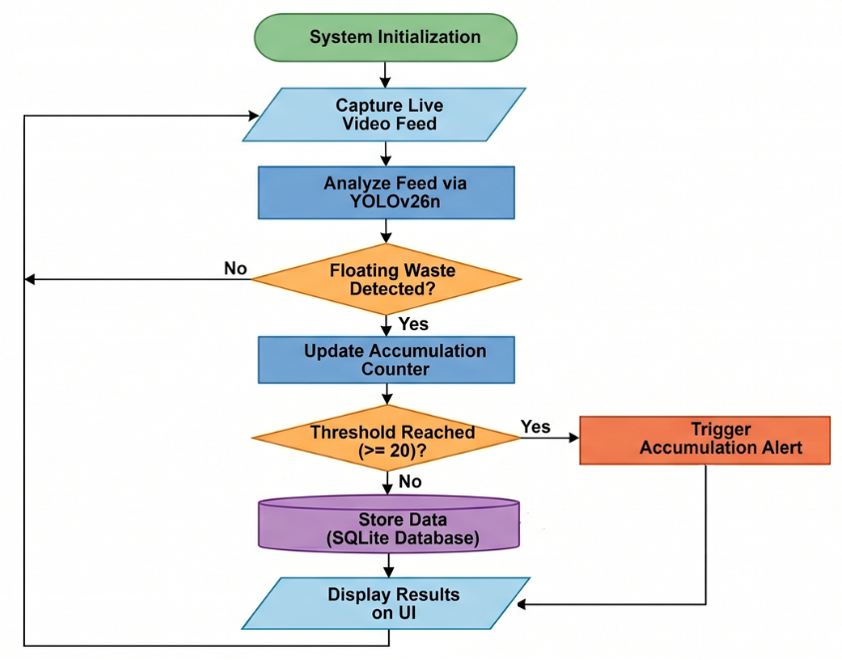
Figure 13 represents the garbage detection and data management process.. It starts with powering on and camera initialization. The system captures a live video feed processing in real-time using YOLOv26n for floating garbage detection.
The system then reaches an initial decision point of whether target garbage (bottles, bags, or food containers) is detected or not. If garbage is detected, the system logs the object, increments the accumulation counter, saves the image and data for further analysis, and updates the statistical records in the SQLite database. In case no garbage is detected, the system simply bypasses the logging sequence and continues to monitor the live feed.
The processed results are displayed on the user interface, allowing for real-time monitoring, configuration, and interaction. The system captures and analyzes the new feeds of video into it continuously such that the floating garbage continues to be recognized rightly to collect data on water pollution levels.
The process is strictly sequential such that the system is first powered and the CCTV camera activates, records live video, and forwards the video for processing. YOLOv26n starts to analyze the video to identify floating garbage.
If garbage is detected, the system checks a secondary decision point regarding the accumulation threshold (set to a default of 20 items). If the threshold is reached, the system triggers an alert for local authorities, saves the picture, and updates the statistical report. If the threshold is not yet met, the system logs the current count and updates the database without triggering the alert, seamlessly looping back to capture the next frame.

3.4 Project Development
Figure 14
V-Model SDLC Model
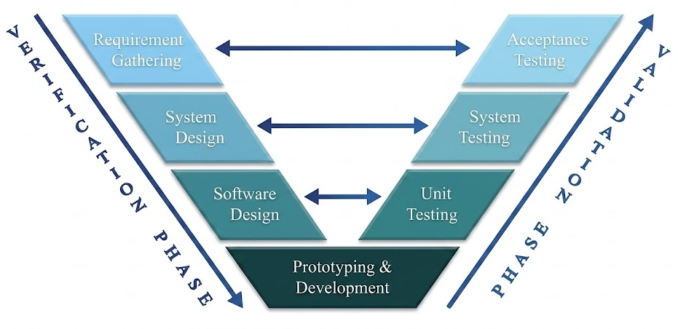
Note. Adapted from “What is the V-model in software development?” by Oppermann & Whitfield, 2025, Built In (https://builtin.com/software-engineering-perspectives/v-model).
The researchers adapted the traditional V-Model Software Development Life Cycle for the Garbage-Guard System to better suit the hardware and software integration requirements for the prototype. Figure 14 shows the relationship for each phase, ensuring that they are systemically combined throughout the development process. This adapted V-Model has three phases which are Verification, Prototyping & Development, and Validation. This approach ensures a smooth and strict relationship between the design parameters and testing protocols so each design and test phase can be conducted in parallel to each other.

1. VERIFICATION PHASE (Left Side of V)
This phase defines the exact parameters the system must meet, and also the design of hardware and software to achieve those goals.

1.1 Requirement Gathering
The researchers consulted with researchers’ thesis advisor Prof. Jonel R. Macalisang, to make the scope and title of the Garbage-Guard project. During the phase, the requirements were specifically defined. Under the guidance of researchers’ Technical Research Advisor, Prof. Ma. Ian De Los Trinos, the criteria for the acceptance testing were accepted using the ISO/IEC 25010:2023 standard. The assessment was limited to two software quality characteristics:
- Functional Stability: To evaluate the accuracy of the garbage detection
- Performance Efficiency: Evaluate the speed and time of detection.

1.2 System Design
In this stage, the researchers planned the physical system architecture and the required components to show portability, and continuous operation. The researchers designed the layout of the hardware, utilizing these components:
- Camera (CCTV) - The sensor for real-time computer vision capture
- Raspberry Pi 5 (8GB) - The core microprocessor that executes the Computer Vision Algorithm.
- Touchscreen Monitor - Display Interface that's mounted on the device to show real-time video feed and log history of detected garbage.
- USB-A Hub: An external interface allowing developers to connect the peripherals to extract those data logs or push updated YOLOv26 model weights after external retraining.
- Raspberry Pi 18650 Lithium Battery UPS Hat: To provide an uninterruptible power supply (UPS), capable of safe shutdowns and power losses.
- AC Power Adapter Cord: To connect the system to an electrical outlet through the UPS.
- Active Cooling Fan: Thermal management recommended to prevent the Raspberry Pi 5 from overheating during AI Processing.

1.3 Software Design
The software architecture was planned across three distinct layers:
- AI / Computer Vision: Utilizes YOLOv26 Convolutional Neural Network (CNN) Algorithm for real-time object detection.
- Front-End (UI/UX): The visual dashboard displayed on the touchscreen monitor, showing live feeds and daily garbage statistics.
- Back-End (Database): A lightweight and local database (e.g., SQLite) Engineered to safely log the garbage classifications, and scores of detected items.
The architecture ensures modularity and separation of concerns between detection, processing, and visualization components.

2. PROTOTYPING & DEVELOPMENT
Serves as the vertex of the adapted V-Model, the phase transitions the project from theoretical designs to physical fabrications. Initial development begins with deploying the YOLOv26 algorithm onto the Raspberry Pi 5 to check core compatibility and functionality. Once it is done, the model shall be trained on custom garbage datasets.
At the same time, the prototype will be fabricated for maximum portability, the components like Raspberry Pi, UPS, and the USB hub, are secured inside a custom made protective case with the touchscreen monitor, and exhaust fan mounted on the exterior. The entire enclosure, along with the top mounted camera, is attached to an adjustable tripod stand, allowing the Garbage-Guard system to be easily deployed on different terrains alongside the creeks or any shorelines.

3. VALIDATION PHASE
This phase moves upward of the V-Model, directly testing the design established in the first phase so that it ensures all mathematical and functional conditions are met.

3.1 Unit Testing
The unit testing phase is the first testing stage on the right side of the V-Model. It evaluates the software and hardware components of the system in a controlled environment. Based on the project’s scope and objectives, this will involve isolating the YOLOv26 algorithm, the accumulation counter logic, and latency logging mechanism on the Raspberry Pi 5 to ensure they will function correctly before the full integration happens.

1. Classification Evaluation
To verify its software components, particularly the object detection algorithm, a custom dataset of 500 testing images is used. The model is mathematically validated using a Confusion Matrix that consists of True Positives (TP), False Positives (FP), True Negatives (TN), False Negatives (FN). Evaluation of the AI Model’s performance is computed based on the following core statistical formulas:
- Precision: Measures the model’s ability to avoid False Positives. It basically measures how many of the items the YOLOv26 model identified as garbage were actually garbage.
Precision$= \frac{TP}{TP+FP}$
- Recall: Measures the model’s ability to detect all the actual garbage that is present. It recalls how many of the actual garbage items present in the water were successfully captured by the YOLOv26 model. In short, the model’s ability to avoid False Negatives
Recall$= \frac{TP}{TP+FN}$
- Accuracy: The overall correctness of predictions. This is the ratio of the correct predictions to the total number of cases examined. Model must meet a baseline classification accuracy of at least 80%
Accuracy$= \frac{TP + TN}{Total Objects} × 100$

2. Accumulation Detection Evaluation (Counter Logic)
To mathematically determine if the system correctly tracks item counts and triggers the “Accumulation Alert” at the 20-item threshold, simulated accumulation test cases are conducted.
Success Rate: Measures the percentage of successful alert triggers out of the total number of simulated trials.
Success Rate$= \frac{Number of Successful Alerts }{Total Number of Trials }$ $× 100$

3. Performance Efficiency Evaluation
Measures real-time responsiveness of the Raspberry Pi 5, the system automatically checks the latency of each frame.
Average Latency: Evaluates the mean inference time (in seconds) across a test duration to ensure that there is no severe hardware degradation. It is calculated by subtracting the frame capture timestamp (Start Time) from the detection completion timestamp (End time).
Average Latency$= \frac{∑ ( T_{End} -T_{Start} )}{Total Frames}$
Table 3
Unit Testing Cases for Controlled Environment Evaluation
Test Case ID | Objective | Procedure | Expected Result
TC_UNIT_01 | Evaluate Classification Precision and Accuracy | Feed the 500 testing images of the 3 target categories ( Bottles, Bags, Food containers) into the YOLOv26n model. | Model correctly classifies the garbage types with a baseline accuracy of at least 80%, successfully ignoring non-target categories
TC_UNIT_02 | Validated Accumulation Counter Logic | Programmatically simulate the continuous detection of floating garbage items, incrementing up to the default threshold | The system correctly tallies the items and triggers the automated “Accumulation Alert” exactly when the 20-item threshold has been reached.
TC_UNIT_03 | Verify the Performance Efficiency Logging | Run sample video frames through Raspberry Pi 5 to execute the latency tracking script. | The system calculates latency successfully by subtracting the start time from end time without hardware crashing.

3.2 System Testing
Once the units are verified, System Testing is conducted. This phase tests the fully integrated system, consisting of the Raspberry Pi 5, the camera, the YOLOv26n Model, and the alerting logic. Prototype is deployed at a local creek or barangay site for real-world environmental monitoring. It ensures that the system can handle real-time video feeds, tracks only visible floating surface items (Excluding sunken or heavily obscured garbage), and maintains efficiency in processing without the worry of severe hardware degradation under the continuous load.
Table 4
System Testing Cases for Real-World Environmental Conditions
Test Case ID | Objective | Procedure | Expected Result
TC_SYS_01 | Real-World Object Detection. | Deploy the setup beside the waterways/creek and stream the live footage onto the Raspberry Pi 5 for real-time analysis | Bounding boxes are accurately drawn over visible floating bottles, bags, and food containers, ignoring sunken garbage or organic debris
TC_SYS_02 | Real-time Accumulation Alert | Allow the system to continuously monitor the creek until 20 valid targeted garbage items accumulate on the water surface. | Successfully recognizes the threshold breach and triggers the automated accumulation alert in a live setting.
TC_SYS_03 | Real-time Processing Latency | Monitor the edge computing hardware’s responsiveness while processing the live video feed for a standardized test duration. | The average inference latency per frame is logged automatically and remains stable without causing the system to crash or overheat.

3.3 Acceptance Testing
This testing phase aligns itself with the requirement gathering paste of the adapted V-Model. This stage involves presenting the working prototype through a live demonstration in the field to ensure it satisfies the study’s initial objectives.
To ensure an accurate evaluation and establish the clear testing boundaries, this phase will be divided into two distinct testing perspectives: The developer Side (Internal Acceptance) and the end-user side (External Acceptance).

Developer Side Acceptance Testing
The developer side boundary restricts the evaluation purely to the technical performance, hardware stability and algorithmic accuracy of the Garbage-Guard system. The evaluation is conducted strictly by the researchers based on the ISO/IEC 25010:2023 quality standards identified in the study’s scope. During the live demonstration, the researchers will observe the system’s performance to check if the prototype meets the required percentage averages and latency metrics.
Table 5
Acceptance Testing Evaluation Test Cases
Test Case ID | Objective | Procedure | Expected Result
TC_ACC_01 | Functional Suitability (Classification) | Conduct a live field demonstration to evaluate the percentage average of correct garbage recognition against total samples. | The system achieves a target of “Good” (80%) or better in successfully classifying the 3 target garbage types.
TC_ACC_02 | Functional Suitability (Accumulation Detection) | Conduct a live field demonstration to check the percentage average of successful alerts triggers. | System achieves a target of “Good” (80%) or better in successfully triggering alerts when reaching the 20-item threshold
TC_ACC_03 | Performance Efficiency (Latency and Stability) | Review internal logs generated during the live demonstration to assess edge computing latency | Raspberry Pi 5 maintains a target average inference time of “Good” (1.51s - 3.0s) or faster (Below 1.5s) Without crashing.
During the demonstration, the stakeholders will observe the system’s field performance to verify if the prototype meets the requirement percentage averages and latency metrics. The structured test cases for this phase are outlined in Table 5.
To formally quantify the results of the live demonstration, the researchers will evaluate the system using an internal evaluation checklist based on the specific system requirements.
Table 6
Developer-Side Internal Acceptance Indicators
ISO Characteristics | Indicator Code | Evaluation Statement
Functional Suitability  (Target: Algorithm Accuracy) | DEV-FS1 | The YOLOv26n algorithm accurately checks the three target floating garbages (bottles, bags, food containers) while ignoring sunken debris and organic matter.
 | DEV-FS2 | The system’s counter logic reliably triggers the automated “Accumulation Alert” exactly when the 20 item threshold is reached in a live setting.
Performance Efficiency  (Target: Hardware & Speed) | DEV-PE1 | Raspberry Pi 5 processes the video feed with minimal inference latency (Under 3.0 Seconds per frame)
 | DEV-PE2 | Edge computing hardware sustains continuous operations without experiencing system crashes or overheating

End User Side Acceptance Testing
This boundary shifts the evaluation focus away from the software and hardware, focusing on the system’s external interface and its usability. This evaluation will be conducted by the target stakeholders from local barangays who will interact with the system’s touchscreen monitor during the live field demonstration.
To quantify the user acceptance, a survey based on the ISO/IEC 25010:2023 characteristics of Usability will be administered to the stakeholders immediately after the demonstration.
Table 7
End User Side Acceptance Survey Indicators
ISO Characteristics | Indicator Code | Evaluation Statement
Usability  (Target: Interface and Operability) | USR-U1 | Information displayed on the monitor is easy to read and understand.
 | USR-U2 | Visual bounding boxes on the camera feed clearly showed where the garbage is located on the creek.
 | USR-U3 | Accumulation Alert is clear, noticeable and effectively informs when the creek needs cleaning
 | USR-U4 | The system provides helpful insights that would assist local authorities in monitoring creek pollution.

IV. REFERENCES
Acot, F. T., Sajorne, R. E., Omar, N.-A. K., Suson, P. D., Rallo, L. E. E., & Bacosa, H. P. (2022, October 19). Journal of Marine Science and Engineering. Unraveling Macroplastic Pollution in Rural and Urban Beaches in Sarangani Bay Protected Seascape, Mindanao, Philippines, 10(10), 1532. https://doi.org/10.3390/jmse10101532
Al Noman, Z., Li1, F. H., Almukhtar, F., Rahaman, B., Omarov, S. Ray, Shahajan Miah, C., Wang, C. (2022). A computer vision-based lane detection technique using gradient threshold and hue-lightness-saturation value for an autonomous vehicle. International Journal of Electrical and Computer Engineering (IJECE). https://ijece.iaescore.com/index.php/IJECE/article/view/27007
Arante, H. R. C., Sybingco, E., Roque, M. A., Ambata, L., Chua, A. Y., & Gutierrez, A. N. (2025). Development of a secured IoT‑based flood monitoring and forecasting system using genetic‑algorithm‑based neuro‑fuzzy network. Sensors, 25(13), 3885. https://doi.org/10.3390/s25133885
Ayoola, V. b., Osam-Nunoo, G., Umeaku, C. & Awotiwon, B. O. (2024). IoT-driven smart warehouses with computer vision for enhancing inventory accuracy and reducing discrepancies in automated systems. ResearchGate. https://www.researchgate.net/publication/386110610_IoT-driven_Smart_Warehouses_with_Computer_Vision_for_Enhancing_Inventory_Accuracy_and_Reducing_Discrepancies_in_Automated_Systems
Balachandran, N., Talavera O. (2023). Apparatus and method for waste monitoring and analysis (US11788877B2). Google Patents. https://patents.google.com/patent/US11788877B2
Bresolin, T., Ferreira R., Reyes, F., Van Os, J., Dórea, J.R.R. (2022). Assessing optimal frequency for image acquisition in computer vision systems developed to monitor feeding behavior of group-housed Holstein heifers. Journal of Dairy Science.https://www.sciencedirect.com/science/article/pii/S0022030222006324#ceab10
Campbell, D. P., Gormley, M., Kelly, D., Xue, Y., & Stewart, C. (2022). Drainage monitoring apparatus and system (WO2022254204A1). Google Patents. https://patents.google.com/patent/WO2022254204A1/en
Chen, L., Li, G., Xie, W., Tan, J., Li, Y., Pu, J., Chen, L., Gan, D., & Shi, W. (2024). A survey of computer vision detection, visual SLAM algorithms, and their applications in energy-efficient autonomous systems. Energies, 17(20), 5177. https://doi.org/10.3390/en17205177
Chordiya, S. B., Das, S., Garg, R., Jain, V., Kumar, A., Nagpure, S. G., Nagvekar, Y. D., Parlikar, A. S., Regulwar, G. B., Saini, D. K., & Individual. (2020, September 9). AU2020102191A4 - WCM-Smart City: WASTE COLLECTION AND MANAGEMENT UNDER SMART CITY USING IOT - Google Patents. https://patents.google.com/patent/AU2020102191A4/en?q=(WCM-Smart+City:+WASTE+COLLECTION+AND+MANAGEMENT+UNDER+SMART+CITY+USING+IOT)&oq=WCM-Smart+City:+WASTE+COLLECTION+AND+MANAGEMENT+UNDER+SMART+CITY+USING+IOT
Corpuz (2025). Wastewater management in the Philippines: A call for localized solutions and policy integration. Environmental Health Insights, 19. https://doi.org/10.1177/11786302241311529
Das, T., Das, N., Zuthi, M. F. R., Pal, S. K., Kraft E., Thomas H., & Kuehlewindt S. (2025). Plastic waste in marine ecosystems: Identification techniques and policy interventions. Water, Air, & Soil Pollution, 236, 478. https://www.researchgate.net/publication/391870234_Plastic_Waste_in_Marine_Ecosystems_Identification_Techniques_and_Policy_Interventions
Den Hartog, E. D., & Voncken, R. G. H. (2017). System for monitoring water drainage (WO2017089181A1). Google Patents. https://patents.google.com/patent/WO2017089181A1/en
Development Asia. (2024, February 28). Optimizing Municipal Waste Collection in the Philippines through a Smart App. Retrieved March 8, 2026, from https://development.asia/case-study/optimizing-municipal-waste-collection-philippines-through-smart-app
Ella D. M., Lim D. M., Lu B., & Cabauatan, R. (2022). The impact of solid waste management the economic growth in selected OECD countries and Philippines. Journal of Economics, Finance and Accounting Studies, 4(1). https://doi.org/10.32996/JEFAS.2022.4.1.20
Garcia, A., Saez, Y., Harris, I., Huang, X., & Collado, E. (2025). Advancements in air quality monitoring: a systematic review of IoT‑based air quality monitoring and AI technologies. Artificial Intelligence Review, 58(9), 275. https://doi.org/10.1007/s10462-025-11277-9
Gryech, I., Assad, C., Ghogho, M., & Kobbane, A. (2024). Applications of machine learning & I Internet of Things for outdoor air pollution monitoring and prediction: A systematic literature review. Engineering Applications of Artificial Intelligence, 137, 109182. https://doi.org/10.1016/j.engappai.2024.109182
Kang, J., Tariq, S., Oh, H., & Woo, S. S. (2022, February 4). A Survey of Deep Learning-Based Object Detection Methods and Datasets for Overhead Imagery. IEEE Xplore, 10, 20118 - 20134. 10.1109/ACCESS.2022.3149052. https://ieeexplore.ieee.org/abstract/document/9703336
Kim H., Lee S.a, Yu G., & Kang J. (2019, January 4). KR101985436B1 - Cleaning unit using the deep-learning - Google Patents. https://patents.google.com/patent/KR101985436B1/en?q=(floating+trash+detection+deep+learning)&oq=floating+trash+detection+using+deep+learning
Li B., & Wang F. (2020, June 23). CN111767822B - Garbage detection method, related equipment and device - Google Patents. https://patents.google.com/patent/CN111767822B/en?oq=CN111767822B
Liu, N., Liu, P. J., Su, M. R., Zhao, B. H., Liu, Y., Wang, W., & Yuan, Z. F. (2022). Detection and monitoring of waste disposal in an environmental location using artificial intelligence (US11308603B2). Google Patents. https://patents.google.com/patent/US11308603B2
Lee, J., Barquilla, C. A. M., Park, K., & Hong, A. (2024). Urban form and seasonal PM₂.₅ dynamics: Enhancing air quality prediction using interpretable machine learning and IoT sensor data. Sustainable Cities and Society, 117, 105976. https://doi.org/10.1016/j.scs.2024.105976
MacAfee, E. A., & Löhr, A. J. (2023). Multi-scalar interactions between mismanaged plastic waste and urban flooding in an era of climate change and rapid urbanization. WIREs Water. https://doi.org/10.1002/wat2.1708
Magyar, D., Cserép, M., Vincellér, Z., & Molnár, A. D. (2023, March 25). Waste Detection and Change Analysis based on Multispectral Satellite Imagery. arXiv, 18. https://doi.org/10.48550/arXiv.2303.14521
Meijer, L. J., van Emmerik, T., van der Ent, R., Schmidt, C., & Lebreton, L. (2022, April 30). More than 1000 rivers account for 80% of global riverine plastic emissions into the ocean. Science, 7(18). 10.1126/sciadv.aaz580. https://www.science.org/doi/10.1126/sciadv.aaz5803
Murat, A. A., & Kiran, M. S. (2025, October 20). A comprehensive review on YOLO versions for object detection. Science Direct, 70. https://doi.org/10.1016/j.jestch.2025.102161
Narayana, T. L., Venkatesh, C., Kiran, A., Babu, J. C., Kumar, A., Khan, S. B., Almusharraf, A., & Quasim, M. T. (2024). Advances in real time smart monitoring of environmental parameters using IoT and sensors. Heliyon, 10(7), e28195. https://doi.org/10.1016/j.heliyon.2024.e28195
Nežerka,V., T. Zbíral, J. Trejbal. (2023). Machine-learning-assisted classification of construction and demolition waste fragments using computer vision: Convolution versus extraction of selected feature. Expert Systems with Applications. https://www.sciencedirect.com/science/article/abs/pii/S0957417423020705
Ng, C. H., Mistoh, M. A., Teo, S. H., Galassi, A., Ibrahim, A., Sipaut, C. S., Foo J., Seay J., Taufiq-Yap, Y. H. & Janaun, J. (2023). Plastic waste and microplastic issues in Southeast Asia. Frontiers in Environmental Science, 11, 1142071.https://doi.org/10.3389/fenvs.2023.1142071
Oppermann, A., & Whitfield, B. (2025, June 18). What is the V-model in software development? Built In. https://builtin.com/software-engineering-perspectives/v-model
Robles, K. P. V., & Monjardin, C. E. F. (2025, June 26). Assessment and Monitoring of Groundwater Contaminants in Heavily Urbanized Areas: A Review of Methods and Applications for Philippines. Water 2025, 17(13), 1903. https://doi.org/10.3390/w17131903
Shao, Z., Li, Y., Liu, B., Quan, Y., Liang, Y. (2023). Method and system for flood early warning in smart cities based on the Internet of Things (US11721191B1). Google Patents. https://patents.google.com/patent/US11721191B1
Te, M. C. L., Bautista, J. A. T., Dimacali, S. M. E. V., Lood, A. V. M., Pangan, M. G. M., & Chua, A. Y. (2024). A smart IoT urban flood monitoring system using a high‑performance pressure sensor with LoRaWAN. HighTech and Innovation Journal, 5(4), 918–936. https://doi.org/10.28991/HIJ-2024-05-04-04
Torres, J. M., Adrian, E. S., & Cook, R. C. (2024). Flood warning system (US12094320B2). Google Patents. https://patents.google.com/patent/US12094320B2
UNEP. (2023, May 16). Turning off the Tap: How the world can end plastic pollution and create a circular economy. UNEP. Retrieved March 10, 2026, from https://www.unep.org/resources/turning-off-tap-end-plastic-pollution-create-circular-economy
United Nations. (n.d.). The 17 goals. Department of Economic and Social Affairs Sustainable Development. https://sdgs.un.org/goals
Victoriano, J. M., Delos Santos, M. L. C., Vinluan, A. A., & Carpio, J. T. (2022, February 12). Predicting Pollution Level Using Random Forest: A Case Study of Marilao River in Bulacan Province, Philippines. International Journal of Computing Sciences Research, 3(1), 151-162. https://doi.org/10.48550/arXiv.2202.06066
World Bank (2022, March 21). Philippines: Plastics Circularity Opportunities Report. World Bank Group. Retrieved March 10, 2026, from https://www.worldbank.org/en/country/philippines/publication/market-study-for-philippines-plastics-circularity-opportunities-and-barriers-report-landing-page
Wu, P., Wang T., Wang G., & Zhang X. (2019, November 28). CN110884791A - Vision garbage classification system and classification method based on TensorFlow - Google Patents. https://patents.google.com/patent/CN110884791A/en?q=(Ai+trash+detection)&oq=Ai+trash+detection
Yang, B., Zhang, B., Zhang, Q., Wang, Z., Dong, M., & Fang, T. (2022). Automatic detection of falling hazards from surveillance videos based on computer vision and building information modeling. Structure and Infrastructure Engineering, 18(7), 1049–1063. https://doi.org/10.1080/15732479.2022.2039217
Yaseen, M. (2024, August 28). What is YOLOv8: An In-Depth Exploration of the Internal Features of the Next-Generation Object Detector. arXiv. arXiv:2408.15857v1. https://arxiv.org/html/2408.15857v1
Zeng, F., Pang, C., & Tang, H. (2024). Sensors on Internet of Things systems for the sustainable development of smart cities: A systematic literature review. Sensors, 24(7), 2074. https://doi.org/10.3390/s24072074

V. APPENDICES
Figure 15
Garbage-Guard’s Gantt Chart
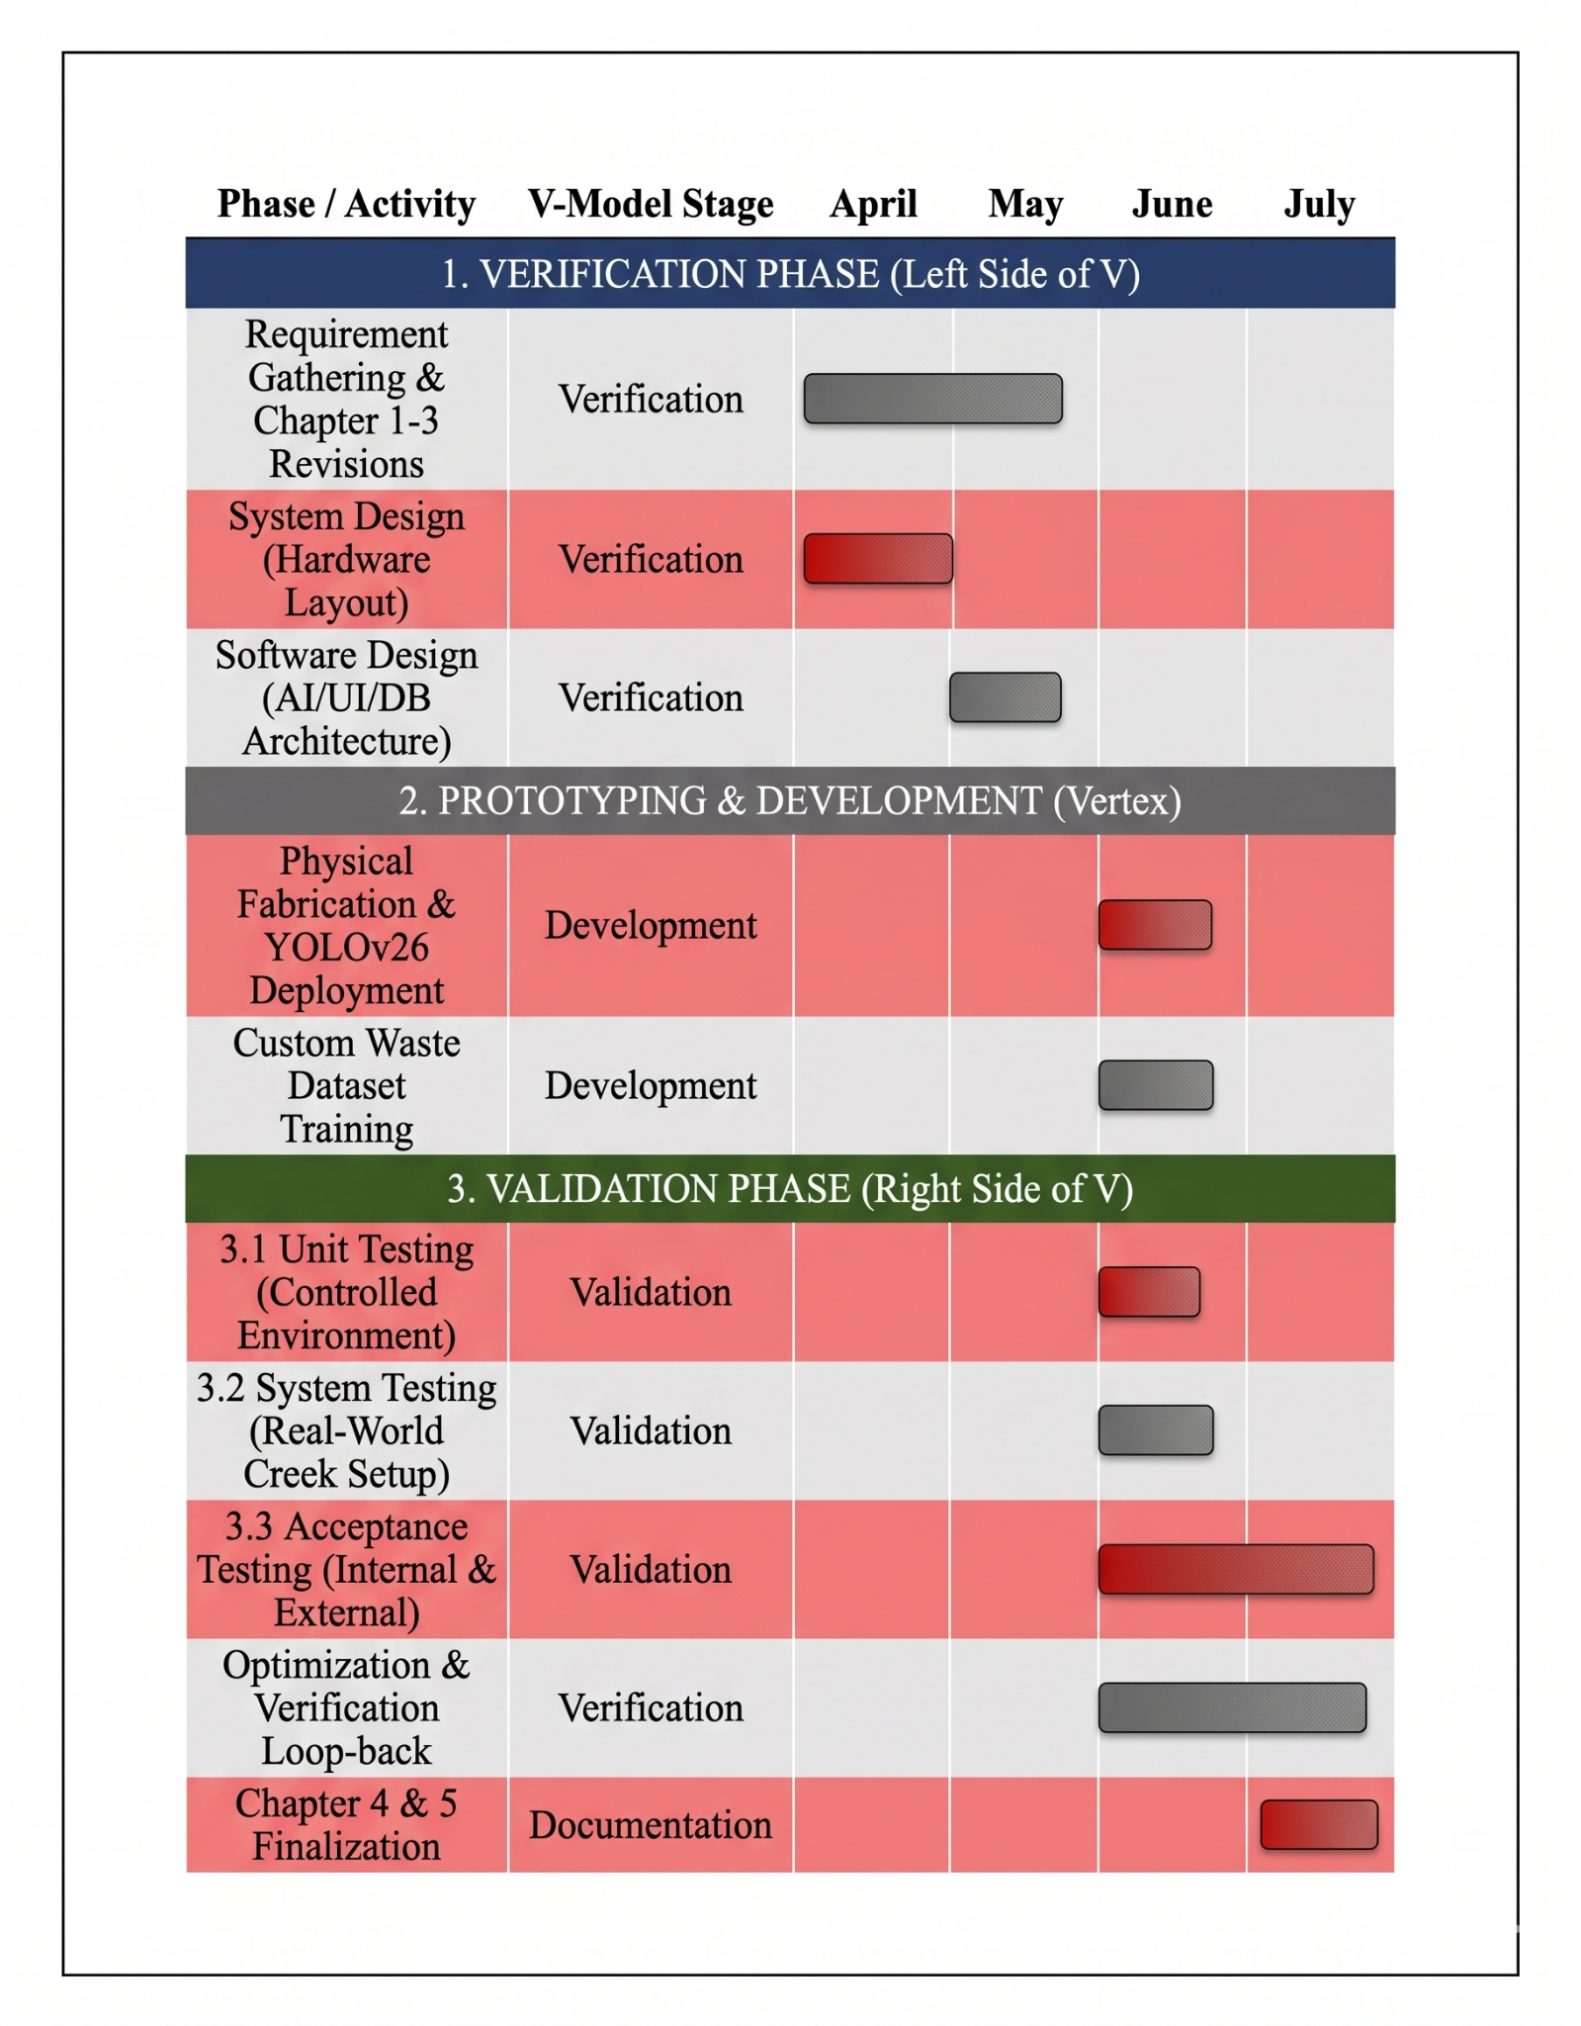

VI. STUDENTS’ BIONOTE
Brian Jay Celeste, a student enrolled in Computer Engineering Technology at the TUP - Manila and achieved N3 certification in the Japanese Language Proficiency Test (JLPT). He works on software development, artificial intelligence, embedded systems, and electronics as his primary technical focus areas. The study designates him as the main project developer who develops the system architecture and trains the YOLOv26 garbage detection model through computer vision.
Genesis Walter D. Reyes II, a Computer Engineering Student in Technological University of the Philippines. He mainly focuses on his interests in both hardware and software. The study designates him as the second project developer who helped train the YOLOv26 garbage detection model.
Jade C. Gunayan, a Computer Engineering Student in Technological University of the Philippines. He conducts research testing and statistical analysis to verify the thesis prototype system's trustworthy performance.
King Perth G. Pepito, a Computer Engineering Technology student at the Technological University of the Philippines. His current research project work involves analyzing systems, designing organizational rules, and proofreading research documentation to guarantee the successful execution of the project.
Rodel S. Banogbanog, a Computer Engineering Technology student at TUP-Manila with interest in both hardware and software technologies, also achieved Certification of NCII of CSS and NCII of Electrical Installation. He focuses on creating intelligent systems through his development work. In this study, Banogbanog handles the project fabrication and design actualization.

